Bootstrap Components Tasks

Task 1 — Responsive Navbar
Code:
<nav class="navbar navbar-expand-lg navbar-dark bg-dark">
<div class="container">
<a class="navbar-brand" href="#">MySite</a>
<button class="navbar-toggler" type="button" data-bs-toggle="collapse" data-bs-target="#menu">
<span class="navbar-toggler-icon"></span>
</button>
<div class="collapse navbar-collapse" id="menu">
<ul class="navbar-nav ms-auto">
<li class="nav-item"><a class="nav-link" href="#">Home</a></li>
<li class="nav-item"><a class="nav-link" href="#">About</a></li>
<li class="nav-item"><a class="nav-link" href="#">Contact</a></li>
</ul>
</div>
</div>
</nav>
OUTPUT:
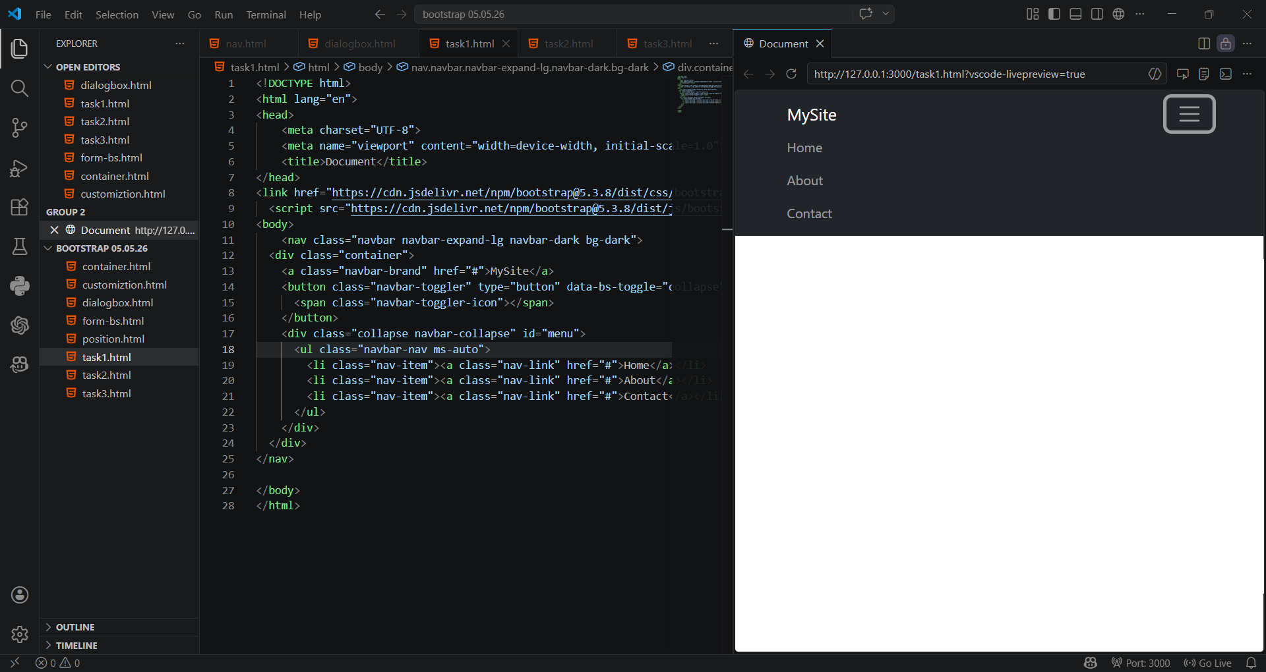
Task 2 — Buttons & Alert
Code:
<button class="btn btn-primary">Primary</button>
<button class="btn btn-success">Success</button>
<button class="btn btn-outline-success">Outline</button>
<div class="alert alert-warning alert-dismissible fade show mt-3">
This is an alert!
<button type="button" class="btn-close" data-bs-dismiss="alert"></button>
</div>

OUTPUT:
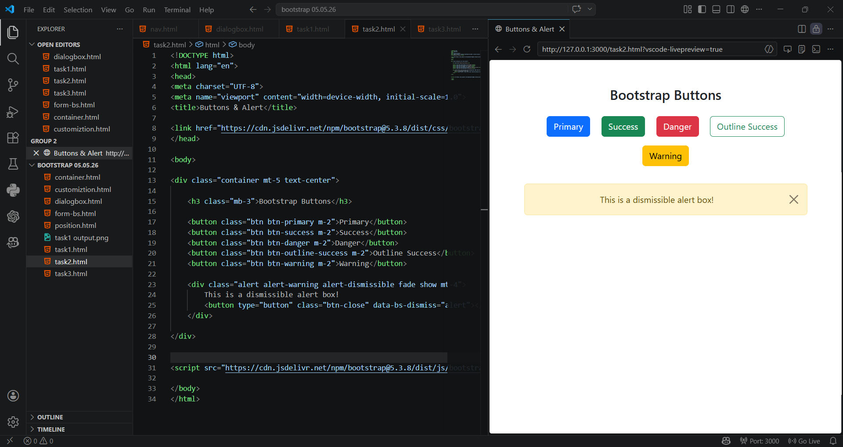
Task 3 — Contact Form
Code:
<form class="container mt-4">
<div class="mb-3">
<label class="form-label">Name</label>
<input type="text" class="form-control">
</div>
<div class="mb-3">
<label class="form-label">Email</label>
<input type="email" class="form-control">
</div>
<div class="mb-3">
<label class="form-label">Message</label>
<textarea class="form-control"></textarea>
</div>
<button class="btn btn-primary">Submit</button>
</form>

OUTPUT:
